**Day 18 Task: Docker for DevOps Engineers**

**Task-1**

Learn how to use the docker-compose.yml file, to set up the environment, configure the services and links between different containers, and also to use environment variables in the docker-compose.yml file.

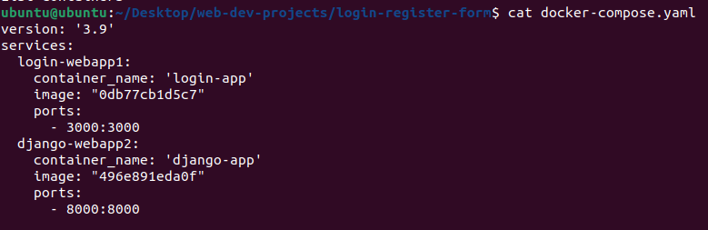

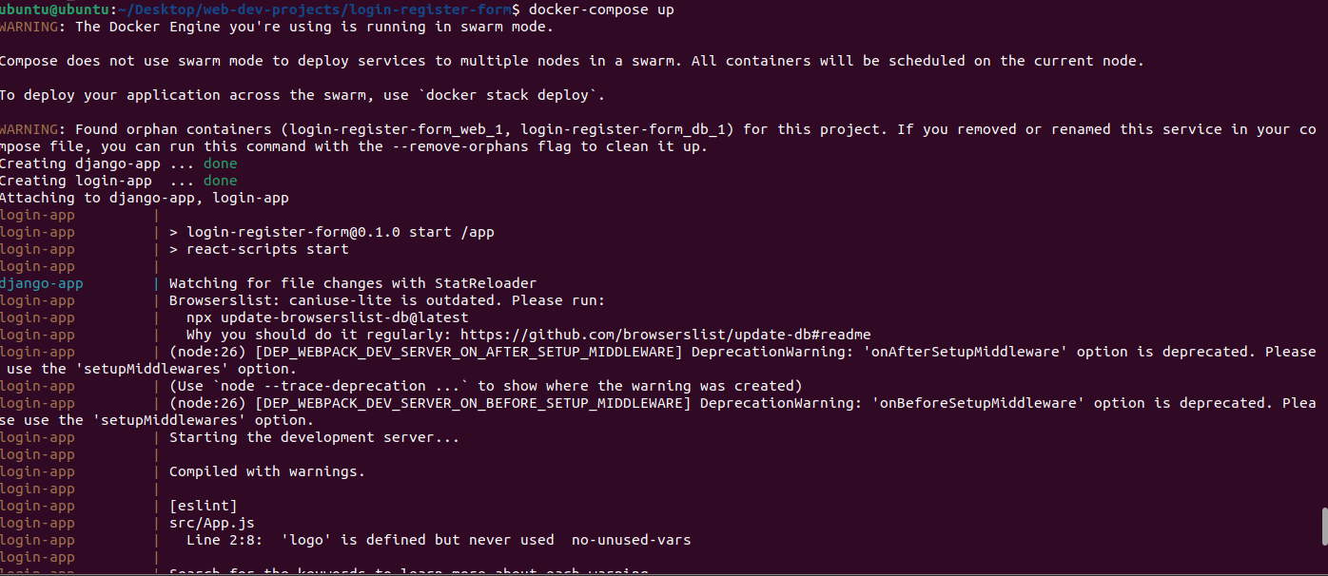

**Task-2**

* Pull a pre-existing Docker image from a public repository (e.g. Docker Hub) and run it on your local machine. Run the container as a non-root user (Hint- Use usermod  command to give user permission to docker). Make sure you reboot instance after giving permission to user.

**Pulled Tomcat image and later runs it and checks the same on port 8080**

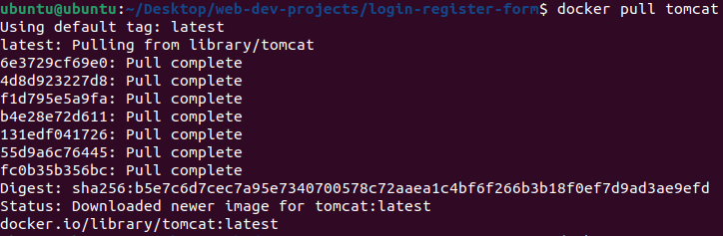

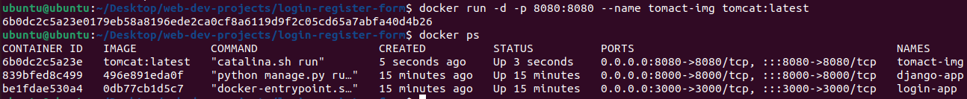

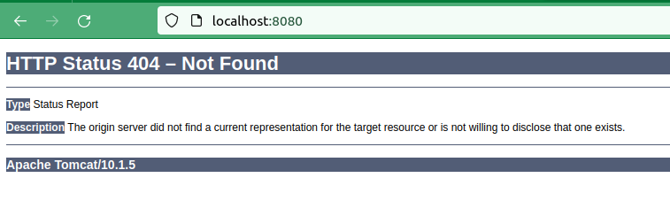

* Inspect the container's running processes and exposed ports using the docker inspect command.

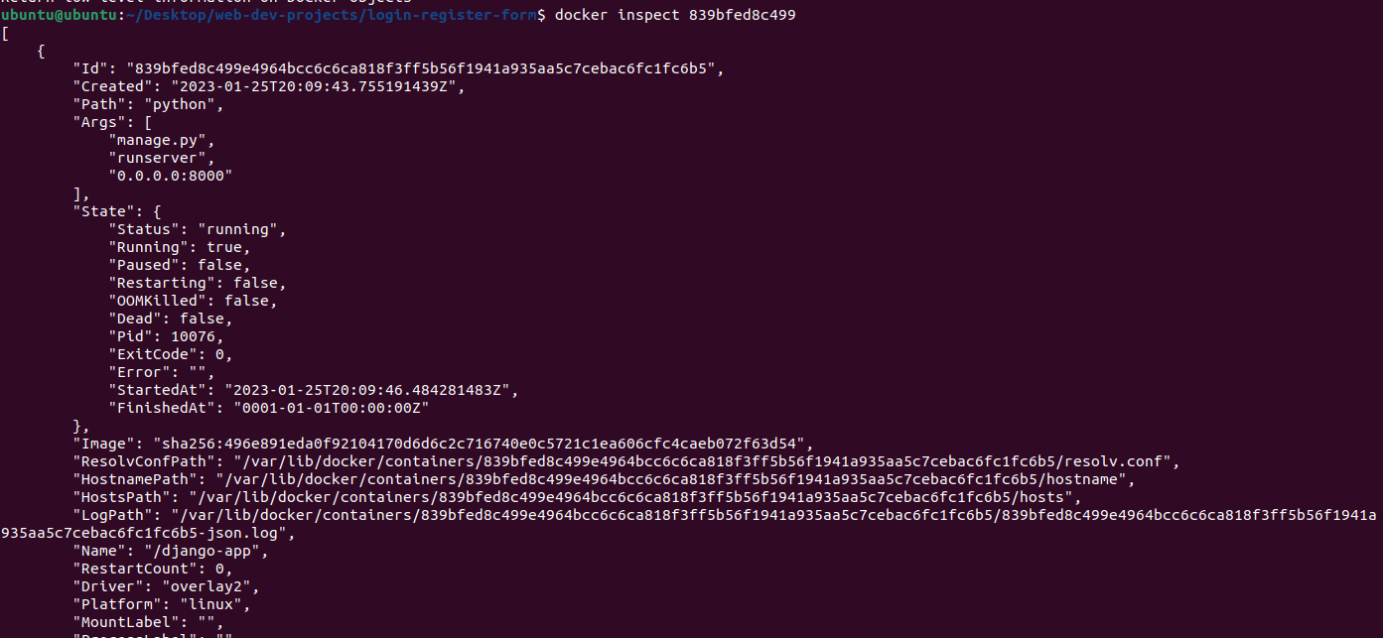

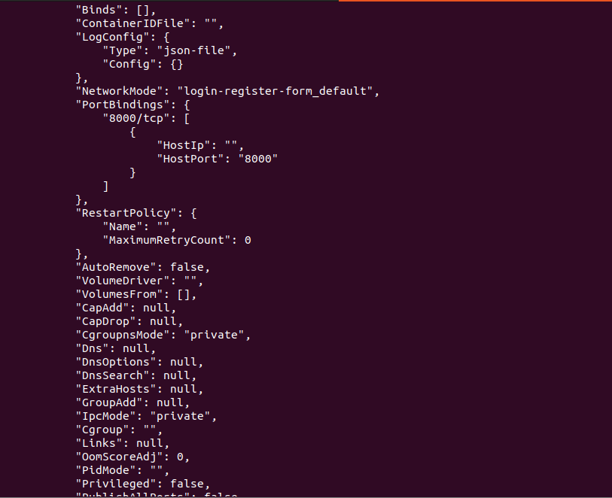

* Use the docker logs command to view the container's log output.

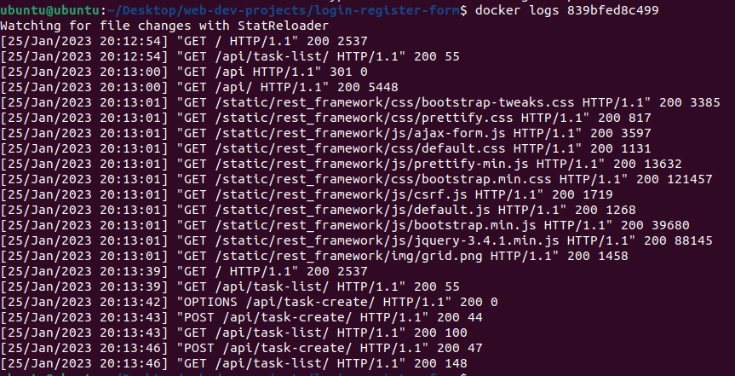

* Use the docker stop and docker start commands to stop and start the container.

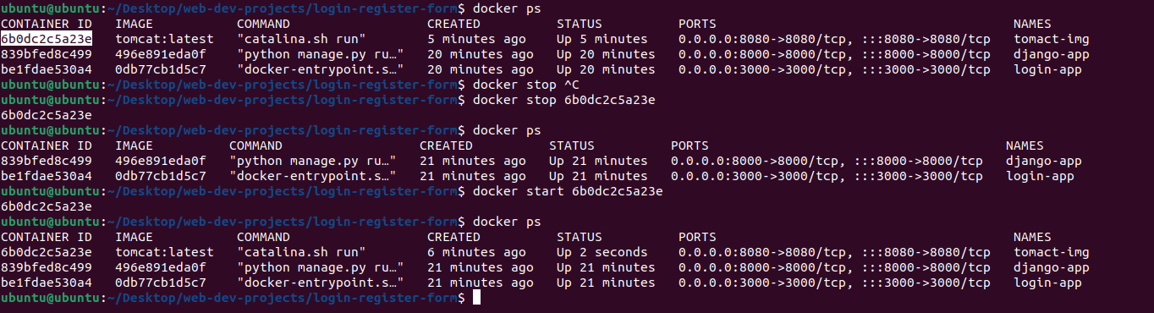

* Use the docker rm command to remove the container when you're done.

